Village of

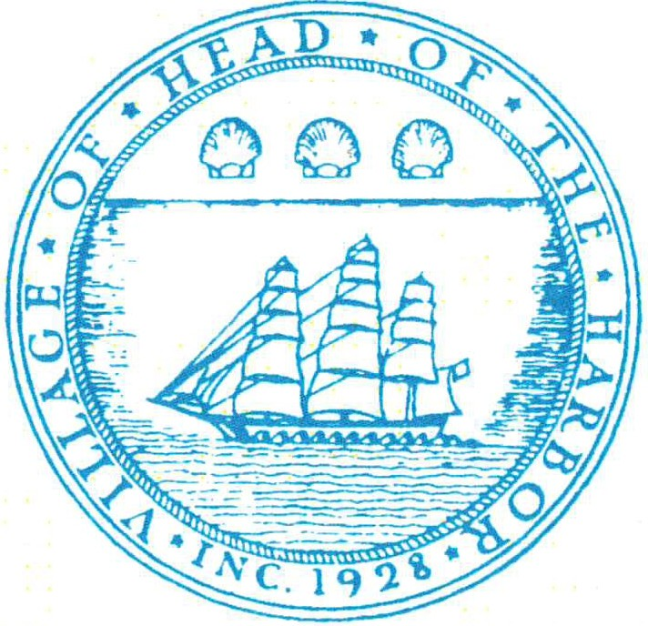
Head-of-the-Harbor

MICHAEL D. UTEVSKY
Mayor

TRUSTEES
LISA DAVIDSON
(Deputy Mayor) JUDITH C. OGDEN JEFFREY D. FISCHER KATHLEEN DIANA
Board of Trustees
Wednesday, October 22, 2025 at 7 PM
WORK SESSION AGENDA

- Appointment- Michael Gargiulo, ARB chairman
- Alert System – Click Send
- Website Privacy Policy
- Microsoft 365
            - Draft Local Laws
            - Discussion on amendments to Tree Code
            - SCWA – Moriches Road Agreement
- 2025/2026 Budget Timeline
- Executive Session – if required

500 N. Country Road St. James, New York 11780
Phone (631) 584-5550
Fax (631) 862-1417
HeadoftheHarborNY.gov

EGAN & GOLDEN LLP
Village Attorney

MARGARET O'KEEFE
Village Administrator/Clerk

PATRICIA A. MULDERIG
Village Treasurer

CHARLES M. LOHMANN
Police Chief

