MINUTES OF THE MEETING OF
THE BOARD OF TRUSTEES
WEDNESDAY, MARCH 4, 2026

The meeting of the Board of Trustees of the Incorporated Village of Head-of-the-Harbor was held on Wednesday, March 4, 2026 at 7 PM at the Village Hall located at 500 North Country Rd., St. James, NY 11780. Those present were the following members Mayor Michael D. Utevsky, Trustee Judith C. Ogden and Trustee Jeffrey D. Fischer. Not in attendance this evening, Deputy Mayor Lisa Davidson and Trustee Kathleen Diana. Also, in attendance Village Administrator/Clerk, Margaret O’Keefe; Village Attorney, Brian T. Egan; Police Chief, Charles M. Lohmann; Building Inspector, Robert O’Shea; Village Treasurer, Patricia Mulderig and Village Engineer, Daniel Falasco. Not in attendance, Dir. of Highway Operations, Frank Prinzevalli.

Pledge of Allegiance.

Mayor - Michael D. Utevsky:

- Update on Harbor Road. No action taken.
- Elections to be held on Wednesday March 18, 2026 12:00 Noon – 9:00 PM.

- It was, upon motion by Trustee Fischer, second by Trustee Ogden, and unanimously adopted:
RESOLUTION #175-25
Minutes of February 4, 2026, 7 PM meeting of the Board of Trustees were presented.
RESOLVED, to adopt the minutes of the above meeting as presented.

- It was, upon motion by Trustee Fischer, second by Trustee Ogden, and unanimously adopted:
RESOLUTION #176-25
WHEREAS, Governor Kathy Hochul released her 30-day amendments to the Executive Budget, which include an additional $100 million in Temporary Municipal Assistance (TMA) to be allocated in the same manner as in the past two years; and

WHEREAS, these additional investments reflect a recognition that New York’s strength begins in its cities, villages, and towns, and that a strong state-local partnership is essential to delivering the services, infrastructure, public safety, and quality of life that residents expect and deserve; and

WHEREAS, local governments across New York continue to face mounting fiscal pressures driven by inflation, increased service demands, infrastructure needs, and rising operational costs, while striving to provide relief to taxpayers amid a rising cost of living; and

WHEREAS, NYCOM Executive Director Barbara Van Epps, along with mayors from across the State, testified at the Local Government Joint Budget Hearing in Albany, advocating for increased unrestricted aid and a strengthened state-local partnership; and

WHEREAS, the additional $100 million in TMA will offer meaningful assistance to many municipalities statewide, helping to address fiscal challenges and maintain essential services for residents;

NOW, THEREFORE, BE IT RESOLVED, that the Village of Head of the Harbor applauds Governor Hochul for recognizing the importance of investing in local governments and for reaffirming her commitment to strengthening New York’s cities and villages; and

BE IT FURTHER RESOLVED, that the Village of Head of the Harbor urges the New York State Legislature to include, at a minimum, this additional $100 million in Temporary Municipal Assistance in the adopted state budget; and

BE IT FURTHER RESOLVED, that the Village of Head of the Harbor calls upon the Governor and the State Legislature to develop a more permanent and predictable solution for unrestricted municipal aid to ensure long-term fiscal stability for New York’s local governments; and

BE IT FURTHER RESOLVED, that copies of this resolution be transmitted to the Governor, the Temporary President of the Senate, the Speaker of the Assembly, and the members of the State Legislature representing the Village of Head of the Harbor.
Financials – Patricia A. Mulderig, Village Treasurer:
- It was, upon motion by Trustee Fischer, second by Trustee Ogden, and unanimously adopted:
RESOLUTION #177-25
RESOLVED, to adopt Abstract Batch #’s 476, 477, 479, 482, 483, 486 and 493 in the total amount of $39,090.49 be paid from the General Fund.

- It was, upon motion by Trustee Fischer, second by Trustee Ogden, and unanimously adopted:
RESOLUTION #178-25
RESOLVED, the village treasurer is authorized and directed to make budget modifications to the 2025/2026 budget totaling $265,115.94 for a net change of zero, as noted:

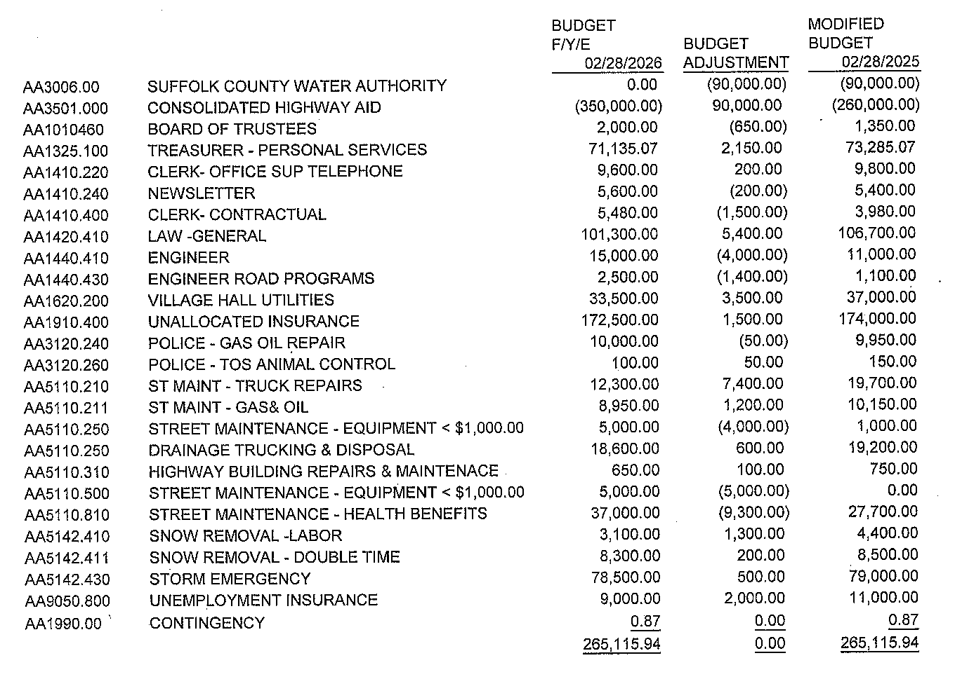
- It was, upon motion by Trustee Fischer, second by Trustee Ogden, and unanimously adopted:
RESOLUTION #179-25
RESOLVED, to authorize and direct the village treasurer to move the awarded JACP grant funds of $3,039.00 from the TD General Fund Account to the Justice Court Account.

- It was, upon motion by Trustee Ogden, second by Trustee Fischer, and unanimously adopted:
The Board of Trustees of the Village of Head of the Harbor has compared the account of unpaid taxes presented by Village Clerk*-Treasurer Patricia Mulderig on March 04, 2026 ("the Account") and the Original Tax Roll for the 2025/2026 Year ("Original Tax Roll"). Pursuant to Real Property Tax Law§ 1436, each Trustee hereby certifies that:
l. the Account has been compared to the Original Tax Roll;
- the Account has been found to be correct; and
- the total amount of taxes unpaid for the 2025/2026 Year is $30,069.47
* Clerk’s note title is only Treasurer.

Highway Department – Judith C. Ogden, Highway Commissioner:
- It was, upon motion by Trustee Ogden, second by Trustee Fischer, and unanimously adopted:
RESOLUTION #181-25
RESOLVED, to authorize and direct the opening of a credit account with Tractor Supply Company for village related purchases by Frank Prinzevalli, Director of Highway Operations with a maximum limit of $2,000.00. This resolution is effective retroactively to February 19, 2026.

- It was, upon motion by Trustee Ogden, second by Trustee Fischer, and unanimously adopted:
RESOLUTION #182-25
RESOLVED, to authorize the expenditure as outlined by the Commercial Driver Training Inc., 600 Patton Avenue, West Babylon, NY proposal dated February 17, 2026, for highway employee Gabriel DeLos Santos.

- It was, upon motion by Trustee Ogden, second by Trustee Fischer, and unanimously adopted:
RESOLUTION #183-25
RESOLVED, to authorize and direct the village clerk to produce a purchase order to Malvese Equipment Co. Inc. for New Holland B75D Tractor-Loader-Backhoe under NYS Contract: PGB-233345, Award: PC 70887, for $89,544.35, minus the trade-in value of $6,500.00 for the 2006 Case580M- Backhoe, for a net expense of $83,044.35.

- Head of the Harbor was granted Tree City Designation for the 8th year.
- Malken correspondence distributed to the Board. No action taken.

Building Department – Robert O’Shea, Building Inspector:
- The Architectural Review Board did not hold a meeting in March.
- Several permits were issued.
- Fire in a residence on Woodlot, no injuries reported.
- Two Zoning Board of Appeal hearings are scheduled for March.

Police Department, Charles M. Lohmann Police Chief:
- Progress for grants is moving slowly.

- It was, upon motion by Trustee Ogden, second by Trustee Fischer and unanimously adopted, to move to executive session to discuss personnel at 7:50 PM. It was, upon motion by Trustee Fischer, second by Trustee Ogden and unanimously adopted, to move back to public session.

- It was, upon motion by Trustee Fischer, second by Trustee Ogden, and unanimously adopted:
RESOLUTION #184-25
RESOLVED, to appoint Carolanne Darrigo as Treasurer and Court Clerk for a two-year terms beginning April 6, 2026 with an annual salary of $75,000.00, subject to a $10,000.00 offset reduction if the employee enrolls in village sponsored health insurance. Serving in concurrent employment, Ms. Darrigo will be classified as a Full-Time employee.

- It was, upon motion by Trustee Ogden, second by Trustee Fischer, and unanimously adopted:
RESOLUTION #185-25
RESOLVED, the village clerk is directed to cancel the Board of Trustees meeting of April 1st and post and publish an Organizational meeting of the Board of Trustees to be held on Monday, April 6, 2024, Village Hall, 500 North Country Rd., St. James, NY 11780 at 7 PM.

There being no other matters to be brought before the Board; it was, upon motion by Trustee Ogden, second by Trustee Fischer and unanimously adopted, to adjourn the meeting at 8:45 PM.

Respectfully Submitted,

_________________________
Margaret O’Keefe
Village Administrator/Clerk

